Index.html File

Line 1 : html tag. Line 3 : head tag. Line-4: title tag and title of site. 6-7: link of css 3 narmalize file. 9-10 : link of style.css file. 12-20: Meta description for search Engine to search content of site.

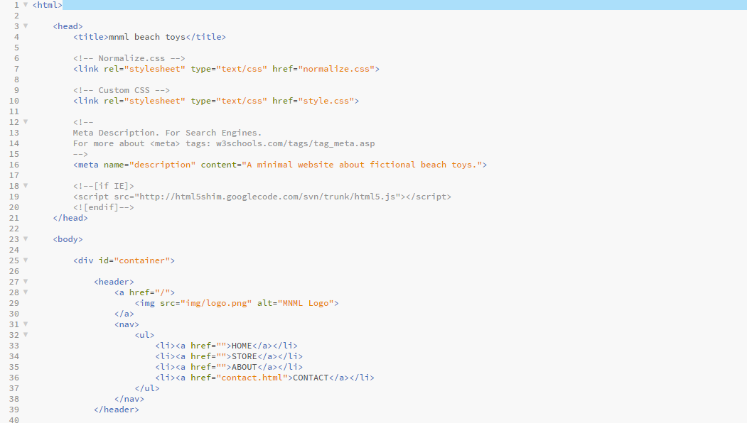

21: head tag close. 21: body tag. 25 div tag and container id. 27. Header tag. 28-30: link of logo image.

31-38: Navigation menu of pages. 39: close header tag.

41: section id of tagline. 42 :heading 1 and emphasiing seriously with emphasize tag and close of tags.

43: button. 44: close of section tag. 46-48 : footer. 50-54 : close of div, body and html tag.

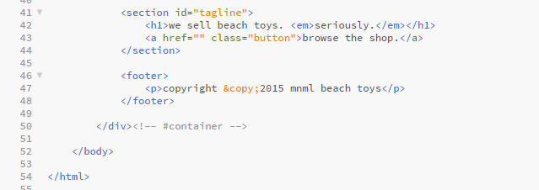

CSS Stylesheet File.

3: body tag. 4: background image link and its alignment. 5: background image size to cover site.

5: Backgroud color. 7: font family. 8. Font size. 9: close of body. 11: container width and margin auto.

11-14: width of container (white border line below navigation menu) and margin 0 means center). 16-20: head text in center and space/padding above and bottom 20 and 0 means in the center. Border-bottom of menu/nav is solid and in white color with 1 px thick.

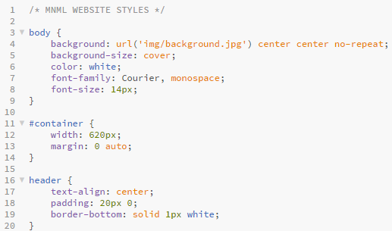

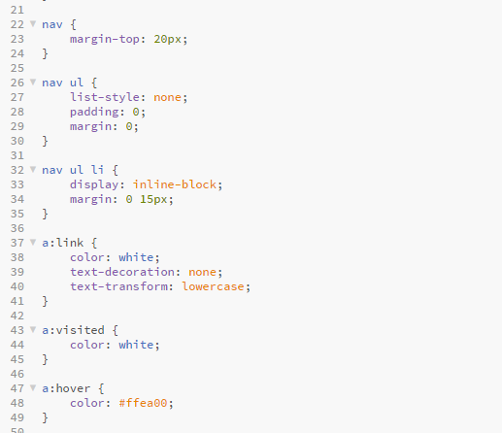

22-24: navigation menu margin above 20px. 26-29: menu in nost in list-style, padding/margin top and bottom o and left and right in between each menu is 15 px. 32-34: navigation ul li Display and margin. 37-39: link color, text-decoration, text-transform. 43: a visited color (when it is touched its color). 47 : a hover color : when mouched with mouse pointer its color changed.

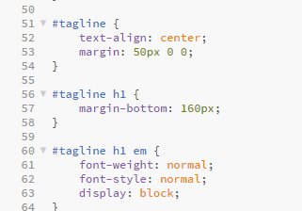

51-52: Tagline: alignment and margin top 50 left and right 0 and bottom 160 56-57: tagline heading 1 margin-bottom 160 , 60-63 : tagline heading 1 emphasis font-weight, style and display style.